**Project Design Document (PDD)**

**Autonomous Coffee Machine**

**Author: Scott White**

**Date: 10/23/2017**

**Revision 1 Date: 12/04/2017**

**Revision 2 Date:**

**Revision 3 Date:**

**Project Design Document_______________________________________3**

1. **Architectural Design_________________________________________________3**
2. **Hardware Design_____________________________________________________9**
   1. State Flow Diagrams___________________________________________________________9
   2. Schematics____________________________________________________________________10
   3. Timing Diagrams_____________________________________________________________11
   4. Theory of Operation__________________________________________________________11
3. **Software Design_____________________________________________________12**
   1. Static Design__________________________________________________________________12
   2. Functional Design____________________________________________________________13
   3. Dynamic Design______________________________________________________________13
4. **Glossary______________________________________________________________13**
5. **Appendixes__________________________________________________________14**
6. **Architectural Design**

The architectural design requires me to build a physical coffee machine that can support multi-cup brewing, two different brews without needing the filters to be cleaned, and remote control accessibility. Being that I am not a mechanical engineer, I decided to take a pre-existing coffee machine and alter and add some components to fit my needs. The machine I currently am trying to prototype with looks like this.

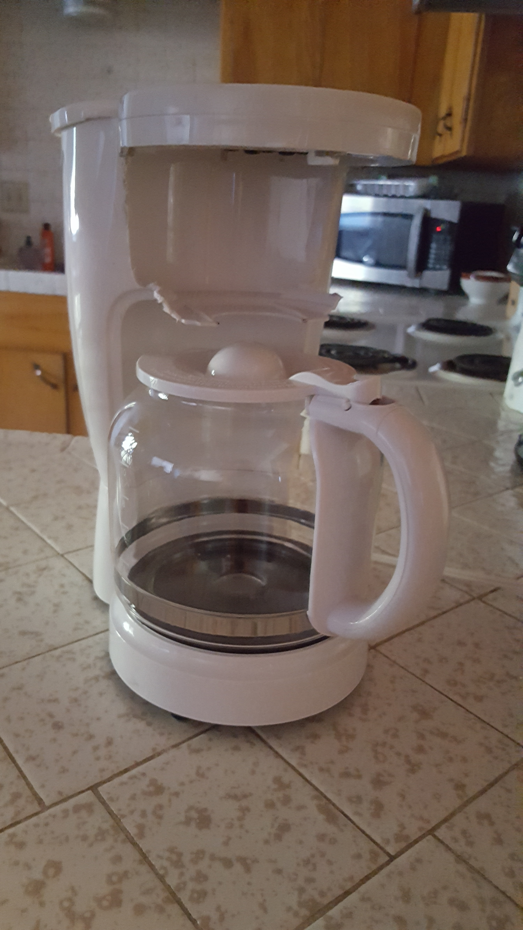

One of the primary components that I need is a carousel that will spin two filters around so the coffee machine can brew three separate times without needing to be cleaned. This is the design for the carousel I will use.

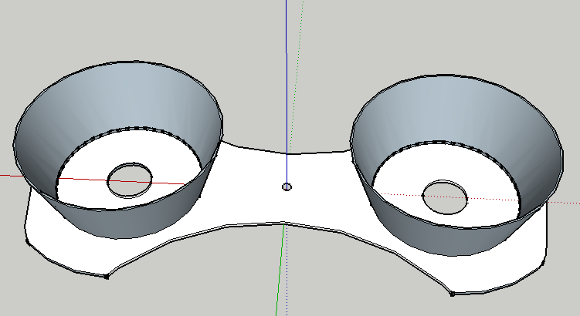

I am also needed to design a shaft for the motor to spin the carousel 200 mm above the counter. For this I used a 130mm M6 all thread rod coupled with an RC airplane motor connector that connects to the DC motor. This is what it looks like.

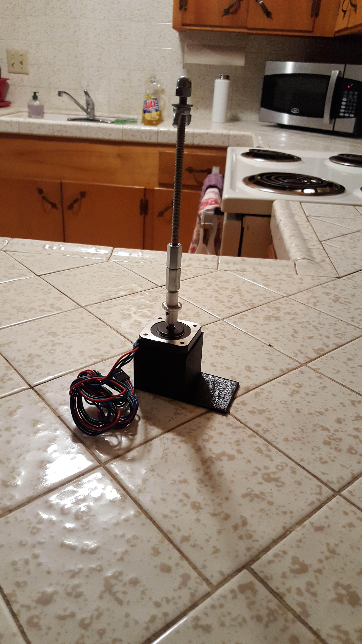

I also needed a means to connect the stepper motor to the coffee machine to keep it from moving, so I designed this motor mount.

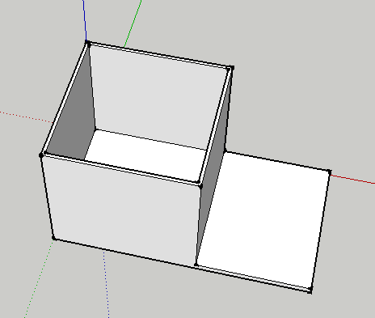

The next thing that needed to be setup were the reservoirs and solenoid valves, but I quickly ran into a problem. How am I going to mount these reservoirs above the coffee machine, so they can flow down into their desired locations without having to fight gravity. After thinking about it for a while I decided the easiest and cheapest way of doing this would be to build a two layer frame for everything to sit on. The coffee machine and the motor and carousel will be on the lower level, and the reservoirs and electronics will be on the upper level. To build this I cut out two 18” x 11” pieces of wood, and used four 36” x 5/16-18 all thread rods to connect the wood. I used 12 5/16-18 jam nuts to secure the wood to the rods, and four 5/16-18 cap nuts as “legs” for the project to rest on. Here is a picture of the frame with most of the components assembled and in place.

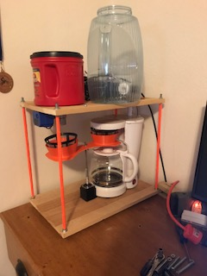 I found an old plastic tea jug that I thought would be a perfect water reservoir for the machine. To attach the water solenoid to the valve I used a faucet nut and a bunch of aquarium safe silicone to prevent any water leaks. On the other side of the valve I connected an ½” PVC elbow followed by a small piece of ½” PVC to guide the water into the coffee machines reservoir. Here is a picture of the setup.

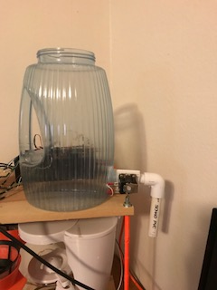

After setting up the water reservoir I came up with a very cheap idea for a coffee reservoir. I decided to drill a hole at the bottom of an old Folgers coffee can as my reservoir. The reservoir sits above the solenoid ball valve, and the ball valve connects to a ¾” PVC neck to extend it above the wooden frame slightly above the bottom of the coffee reservoir. Here is a picture.

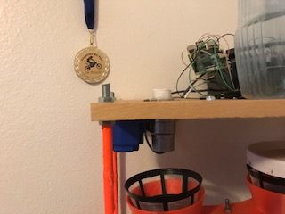

After finishing up setting up the reservoirs I decided to secure the coffee machine and motor mount to the bottom layer of the frame by carefully sinking screws into the coffee machine and motor mount.

The last thing I had to do was build the power supply. You can see the schematics below, but part of the architectural design was to enclose all the electronics. To do this I bought a 7.5”x4.3”2.2” plastic project box to put everything in. I put both of the power supply modules on the lower layer and the majority of the wires as well. Then I cut a slab of perforated circuit board and mounted screws to secure the box, circuit board, and power supplies to the frame. I drilled holes all over the circuit board to secure the relay module and motor driver, as well as holes to insert wires on the side. Here is a picture.

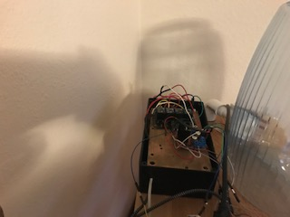

1. **Hardware Design**
   1. **State Flow Diagrams**

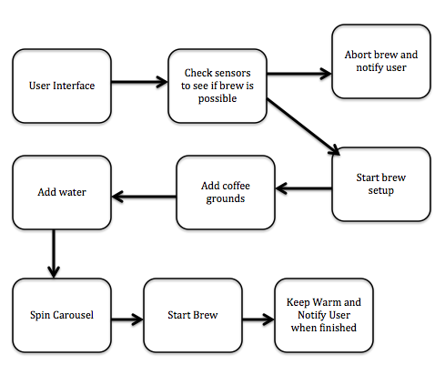

* 1. **Schematics**

12 V Power Supply Schematic

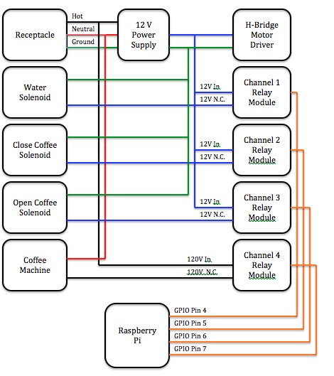

5 V Power Supply Schematic

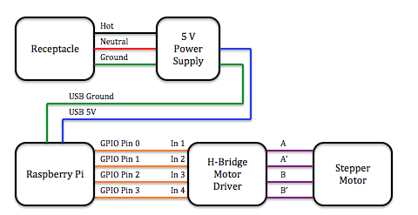

* 1. **Timing Diagrams**
  2. **Theory of Operation**

The user will open up my webpage, which will have a user interface to start a brew with selectable parameters. When the user starts the brew, the machine will be triggered to run and passed the user’s parameters. The machine will first check if there is a clean filter to brew with. If so the machine will continue and if there is not the machine will abort and send a message back to the client reporting that it could not brew until the filters were cleaned. Before starting the brew, the machine will add coffee into the filter based on how many cups and how strong the user wanted their brew. The machine will then add water to the reservoir based on how many cups the user wanted to brew. The machine will then spin the carousel into place and start the brew. Once the brew is finished the machine will keep the coffee warm for a set amount of time.

1. **Software Design**

**3.1 Static Design**

The coffee machine will keep all pots of coffee warm for the same amount of time after the brew has finished. The user interface will be static unless an error occurs. All of the autonomous brewing functionality is dynamic because it changes with the user parameters, but the basic functionality will be the same for all brews.

**3.2 Functional Design**



**3.3 Dynamic Design**

The software will be dynamic in that it will decide whether it can start a brew based on if it has sufficient supplies and a clean filter to set up. It will also be dynamic in that the machine will be brewing different volumes of coffee and different strengths of brews. The user interface will also be reporting to the user when errors occur or when a brew finishes.

1. **Glossary**

Solenoid Valve: An electromechanically operated valve.

Relay: Switches that open and close circuits electromechanically or electronically.

1. **Appendixes**